1. If a user is given folder access permissions, they will be able to view all projects within that folder, regardless of whether the projects are assigned to them or not.
That’s why Clark is able to see all projects in the Active Projects folder on their dashboard.
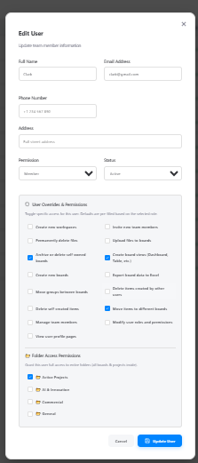
2. Yes, time tracking is enabled intentionally. You can use it to track your work time.
3. First, you need to create the project. After that, you will be able to update or modify it. Then you can select the person, change the status, and man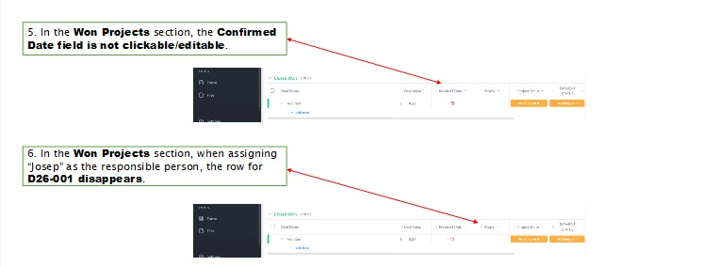age other details accordingly.

